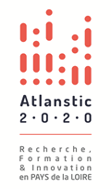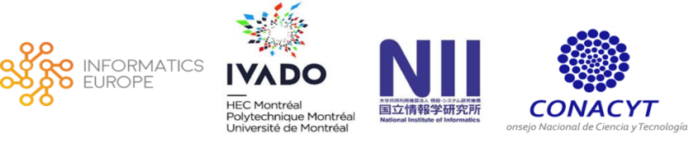

Call for Applications

International Chairs 2018

Atlanstic 2020 is funding experienced researchers from its international partners
for a full year.

Come to develop or strengthen collaborations with Informatics research teams from the Pays de la Loire region of France!

www.atlanstic2020.fr/en/
April, revised June 2018

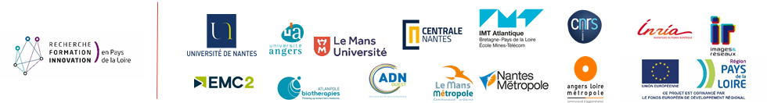

Context
The French regional program Atlanstic 2020 is hiring experienced researchers associated with the following organizations: INFORMATICS EUROPE, IVADO, NII and CONACYT for long stays (12 months renewable) to develop or strengthen collaborations with the following French laboratories: LS2N (Nantes), LARIS (Angers), LERIA (Angers) and LIUM (Le Mans) research teams.
The fields of expertise of these laboratories are:
- Data Science
- Complex Systems
- Content and Interactions
- Software Science
- Robotics
Atlanstic2020 is offering a monthly income based on the candidate profile up to 4 600 € net (out of charges).

Application Conditions

The applicant must:
- Be employed by a member of our international partners:
  - IVADO, Montreal
  - NII, Tokyo
  - Informatics Europe
  - CONACYT, Mexico
- Commit to spend a full year in a laboratory member of Atlanstic 2020,
- Propose a work program related to the objectives of the hosting project-team(s),
- Provide a written authorization by your main employer.
During your visit in Pays de la Loire, you will commit yourself to give seminars or lectures to a large audience and to mention Atlanstic 2020 in any scientific production achieved during your visit.
In delivering an International Chair position, Atlanstic 2020 is committed to remunerate you as a visiting professor and to provide you a working environment at the level of international standards and to remunerate you as a visiting professor at:
- University of Nantes, Centrale Nantes and IMT Atlantique for LS2N
- University of Angers for LARIS and LERIA
- University of Mans for LIUM

How to apply?
The application file must contain:
- A curriculum vitae
- A research project including perspectives for scientific and technological development.
- An invitation letter from the team-leader(s) of the hosting team(s) including written approval from the heads of the welcoming laboratory and the associated establishment.
- A letter of support from a member of the Atlanstic 2020 scientific committee: Hélène Kirchner for Informatics Europe, Katusmi Inoue for NII and Gilles Savard for IVADO.
- Additional recommendation letters or references from international experts are appreciated.

Recruitment process
The candidature package can be submitted any time in the year and are reviewed as soon as practical on a monthly basis by the Atlanstic 2020 executive board. The candidate will receive a response within 8 weeks after the application has been received.
This application file must be sent to: burexatlanstic2020@univ-nantes.fr
A confirmation will be sent out 2 working days maximum after reception.

The chairs are delivered for 1 year. A request can be made to renew the chair one time for an additional year. Renewal requests are to be made two months before the end.

These rules and regulations are subject to change without notice by the organizing members, current candidates and beneficiaries will be notified accordingly as applicable.

