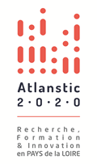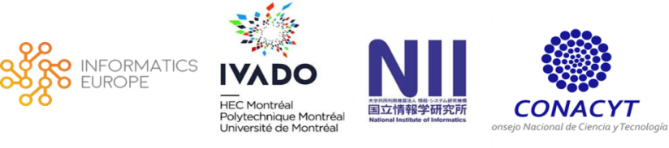

Call for Applications

Visiting Researchers 2018

Atlanstic 2020 is welcoming experienced researchers from its international partners
for up to collaborations of six months over a three years period

Come to develop or strengthen collaborations with Informatics research teams from the Pays de la Loire region of France!

www.atlanstic2020.fr/en/
April 2018, revised June 2018

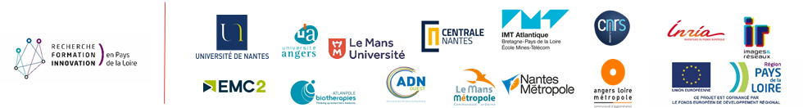

Context
The French regional program Atlanstic 2020 is funding experienced researchers associated with the following organizations: INFORMATICS EUROPE, IVADO, NII and CONACYT for long visits, called “visitor packages”, to develop or strengthen collaborations with the following French laboratories: LS2N (Nantes), LARIS (Angers), LERIA (Angers) and LIUM (Le Mans) research teams.
The fields of expertise of these laboratories are:
- Data Science
- Complex Systems
- Content and Interactions
- Software Science
- Robotics
Atlanstic 2020 is offering a financial package for covering transportation and accommodation costs up to 20 000€.

Application Conditions

The applicant must:
- Be employed by a member of our international partners:
  - IVADO, Montreal
  - NII, Tokyo
  - Informatics Europe
  - CONACYT, Mexico
- Commit to spending up to six months in one or two laboratories members of Atlanstic 2020. The six months can be divided in at most three periods over a period of three years. The dates of the visits being decided with the leader(s) of the hosting team(s) according to a provisional schedule.
- Propose a work program related to the objectives of the hosting project-team(s).
- Provide a written authorization by your main employer.
During your visit in Pays de la Loire, France, you will commit yourself to give seminars or lectures to a large audience and to mention Atlanstic 2020 in all the scientific productions achieved during your visits.
In delivering a Visitor Package, Atlanstic 2020 and its partner laboratories and establishments committed to provide a working environment at the level of international standards at:
- University of Nantes, Centrale Nantes and IMT Atlantique for LS2N
- University of Angers for LARIS and LERIA
- University of Mans for LIUM

How to apply?
The application file must contain:
- A short curriculum vitae
- A research project including perspectives for scientific and technological development and a precise agenda for the visiting periods.
- An invitation letter from the team-leader(s) of the hosting team(s) including written approval from the heads of the welcoming laboratory and the associated establishment.
- A letter of support from a member of the Atlanstic 2020 scientific committee: Hélène Kirchner for Informatics Europe, Katusmi Inoue for NII and Gilles Savard for IVADO.

Recruitment process
The candidature package can be submitted any time in the year and are reviewed as soon as practical on a monthly basis by the Atlanstic 2020 executive board. The candidate will receive a response within 8 weeks after the application has been received.
This application file must be sent to: burexatlanstic2020@univ-nantes.fr
A confirmation will be sent out 2 working days maximum after reception.

Visitor Packages are delivered by Atlanstic 2020 for a 3 years period (max) and cannot be renewed.

These rules and regulations are subject to change without notice by the organizing members, current candidates and beneficiaries will be notified accordingly as applicable.

